**UNIVERSITY OF LONDON**

**BSc Computer Science**



**CM3070 PROJECT**

**PRELIMINARY PROJECT REPORT**

Task Manager Mobile Application

Name: Shanath S/O Rajendran

UoL ID: 210470552

Contents

Introduction 3

Literature Review 4

Time Management 5

The Effectiveness of Goal Visualization 7

Comparison of Existing Applications 9

SWOT 17

Project Design 18

Domain & Users 18

Justification of Selected Features 18

Technology & Methodology 18

Low Fidelity Wireframe 20

User Testing with Wireframe 24

Gantt Chart 25

Feature Prototype 28

References 29

# Introduction

The template chosen for project is the Task Manager Mobile Application, which is derived from the Mobile Development module. I intend to develop, test, and deliver an Android application to the Google Play Store. The reason I will not be developing for IOS devices, and attempt to publish it into the Apple App Store, is due to the fact that I do not own any Apple devices, particularly an iPhone. Therefore, I am limited by my hardware.

The idea for this project comes from my own personal experience, where I have download task manager applications in the past, but have never consistently used them because the application was either not engaging enough, or it was aesthetically unappealing, or both.

**Why is this important?**

We live in a fast-paced world, most of us reside in cities. City life is stressful. We have lots of responsibility and obligations to fulfil on a daily, weekly and monthly basis. We might have multiple places to be in a day. Thus, we need a way to track and manage our tasks. Coupled with the fact that we have too many distractions in the modern world, due to rapidly emerging technology, like social media and games, it can be hard to stay focused on our responsibilities.

The aims for this final project are as follows:

* Build a task manager mobile application for Android
* Allow users to take notes, create a checklist, utilize a timer for time management, and project tool to undertake large scale tasks.
* Deploy it to the Google Play Store
* To have my target demographic review the application, and ascertain if it outperforms what’s currently out on the market.

The deliverables for this final project are as follows:

* An initial preliminary report showcasing the chosen project template and the path ahead.
* The source code for the mobile application.
* A final report detailing the entirety of the project.
* A video demonstration showcasing the mobile application at work.

The following sections will comprise of literature reviews to support the need of having a time management tool, as well as a project management tool. Followed by an overview of the intended audience, technologies and frameworks to be used, wireframes that will be tested by survey respondents, and a Gantt Chart outlining the path ahead in completing this final project.

# Literature Review

In today’s fast-paced and digitally distracting world, effective time management and goal-setting strategies are crucial for achieving success and maintaining productivity for students and young adults. This literature review explores three critical areas to inform the development of a task manager mobile application tailored for this demographic.

Firstly, it delves into time management techniques, examining their impact on productivity and academic performance. As my mobile application will incorporate the 52/17 technique for time management, where the individual will time themselves to work for 52 minutes, and have a 17 minute break thereafter, we need to look into the scholarly works that back up this productivity technique of taking intermittent breaks.

Secondly, it investigates the importance of goal setting and goal visualization, highlighting their roles in motivating and guiding individuals through their projects, as my mobile application intends to offer the function for individuals to track and manage projects, while providing a means to visualize their progress.

Lastly, it offers a comparative analysis of existing productivity apps, identifying key features and shortcomings to ensure our app addresses unmet needs.

By synthesizing insights from these areas, this review aims to establish a robust foundation for creating a mobile application that enhances productivity and supports the goals of students and young adults.

## Time Management

This section will encompass a literature review pertaining the topic of time management. The review will analyze two studies done by experts in the field, in chronological order, to uncover any trends or patterns that have been established over the years.

Nasrullah and Khan from the University of Peshawar and Gomal[1], conducted a study in 2015 to identify the strength and weaknesses of time management practices on student’s academic performance. The study was conducted due to the fact that today’s modern setting requires proper time management in order to stay competitive in an organizational setting[2]. The time management practices consist of time management mechanisms and goal setting. The subjects for this study were students from Qurtuba University of Science and Technology, Pakistan. Surveys was utilized to measure the student’s capabilities of short-term and long-term time management. The data analysis included descriptive statistics to summarize the data and correlation analysis to examine relationships between time management practices and academic performance.

The results, tabulated in a table, showed a positive correlation between time management and the student’s academic performance. It revealed that there is a connection when it comes to academic performance and stress reduction, when utilizing time management practices.

The study showed relevance and practicality to address the issue of student’s academic performance as well as using robust analytical tools to tabulate their findings. However, the sample size chosen was rather small, only a total of 120 students, lacking diversity of participants form various regions. Therefore, care has to be taken as it may not be wise to generalize the findings to all student populations globally.

A study conducted by Albulescu and colleagues, from the University of Timioara, Romania[3], published August 31 of 2022, delved into the effectiveness of taking micro-breaks and its impact on performance. The study was an analysis of conducted studies in the relevant field over the last 30 years on the subject of micro breaks, on whether taking short breaks of 10 minutes or less, when performing a task, leads to better performance and final outcome without accumulating too much mental and physical wear on the person to the point where is it detrimental to their health.

This investigation was motivated by the ever-increasing workload demands placed on individuals in today's modern and digitized world. The authors aimed to explore whether micro-breaks could serve as a viable solution to reduce the mental and physical strain associated with this growing burden.

Out of 4868 case studies drafted, 22 studies were finalized and narrowed down for the analysis. The participants chosen in the selected studies were healthy individuals which included both students and young adults. The measurements that were monitored and classified in this analysis were vigor, fatigue or performance. Vigor being an individual’s inclination to carry on with the task at hand, even when challenges present themselves, while fatigue relates to how tired the individual is. The performance measurements relate to whether the individual was able to perform his or her task with high degree of accuracy and precision. The tasks the participants had to perform were classified into three categories. Creative, clerical and cognitive tasks. All 22 studies had a control group as a comparison, such as those with micro break and those without.

The collective findings of the chosen studies concluded that micro breaks do indeed improve the performance and vigor of the individual whilst reducing fatigue for clerical and creative tasks, though there was barely any improvement for cognitive intensive tasks. The data uncovered that those who took breaks that were longer than 10 minutes, generally had better performance.

However, there were several key factors that had to be considered for further study. The duration of the micro break, till this day, could not be decisively agreed upon by experts in the field. The tasks in which an individual partakes prior to the break, also mattered greatly, as well as the activity the individual partakes during their break. An improvement to this analysis could have been taking the findings of the conducted studies, and perform a new bespoke experiment, comparing the results of different intervals of rest period between control groups. I also uncovered that the country in which these case studies were selected from was not mentioned, only that they were taken in English. Perhaps a comparative study could be made between individuals form different regions of the world, like Asia and Europe, to see if there were any noticeable differences in performance when micro-breaks were given. It shared a similar weakness from the first study reviewed, where diversity was lacking.

In summary, this literature review analyzed two studies that took place in 2015 and 2022, highlighting the importance and relevance of the subject of time management in today’s world. The findings revealed that time management practices such as planning and intermittent breaks, improved an individual’s performance when undertaking a task, such as studying or working. This relates back to the need of having a focus tool in a task manager application. The incorporation of the proposed 52/17 technique for time management, is supported by the current literature, in aiding students to focus better when studying, and help plan their study schedules, based off the timer that will indicate how long they should study(time management), and the duration of break(micro-breaks) they should take to recuperate.

## The Effectiveness of Goal Visualization

A research conducted by Cheema and Bagchi[4], published on August of 2010, was done to understand the connection visualizing goals has to an individuals continued effort to complete objective that has been undertaken. The analysis aims to illustrate that intuitive goals are interpreted to be easier for an individual to reach, rather than a goal further out in a given timeframe, especially when it’s broken down into sub-tasks. The research was conducted to contribute to this field of study by demonstrating how easy it is to use visualization to increase the efficiency of pursuing a goal, to identify that visualization makes the objective appear nearer, thus increasing the output exerted and demonstrate the power of visualization and reveal the boundaries conditions, particularly when the objective is framed in a consolidated manner.

A total of five studies were conducted to assess the effects of goal visualization.

The first study took 68 Olympic swimmers and had them swim 30 laps, each of which was a 100m. The measurements used was to take the difference in swim times of the first 50m, when the swimmer was facing away from the finish line, and the last 50m, when the swimmer was able to see the finish line, hence, able to visualize the end goal. The results revealed that the time difference decreased as the swimmer neared the finish line, showing a positive influence on the swimmer when he was approaching the goal, despite the presence of fatigue.

The second study took 79 students and had them sustain grip pressure for 130 seconds. The students were split into to two groups, where one had a horizontal progress bar to view on a screen, whilst the other could only view a stopwatch at 30 seconds intervals. The results found that the pressure exerted from students who were given the stopwatch, decreased significantly towards the end, compared to those who could view the horizontal progress bar, and were able to sustain a more uniform pressure. This test suggests the importance of goal proximity and in relation to effort.

The third study took 183 undergraduates and tasked them to save $750 for a fabricated vacation to Europe. There were two groups, one that could easily visualize their savings with a horizontal bar that was shaded depending on how much was already saved, 30% or 70%, whilst the other control group was only given textual representation of the savings amounts. The measurements used was a scale given to the participants to assess their commitment to reaching the required amount. The scale was based off Wright and Kacmar[5]. The results revealed those given the bar that made visualizing the amount left to save up, committed greater effort to saving than those that had a difficult time visualizing.

We can see from the first three studies alone, they examined the subjects in settings where either their physical or mental fortitude, or both, was required to complete the tasks in various environments. And in all scenarios, the group that was able to visualize their goals, with either a horizontal progress bar, or being physically able to see the ending of the tasks, outperform the control group that either could not visualize it, or were given a poorer visualization. The findings of this review do indeed suggest that having a form of goal visualization does indeed encourage individuals to exert more effort and increase their motivation in completing their objective. The findings here support the need of having a project management tool in my task manager application, that allows users to visualize their milestones and their accomplishments, while providing an easy to visualize progress bar as to how much is left to accomplish.

However, the studies conducted above do leave room for question as to the factors that could contribute to how likely an individual is able to outperform another, given that both has access to easy visualization tools. For example, the undergraduates whose grip strength was tested, could house bias to the strength of the individual. A student with phenomenal grip strength and endurance could exert the most amount of willpower and willingness to complete the test, regardless of what goal visualization tool he was given. Thus, it is important to note an individual’s characteristics and personality might be a contributing factor when to comes to accomplishing goals.

## Comparison of Existing Applications

The following is a critical review of similar applications that have already been published in the market. These competitors were selected for analysis due to their popularity on the Google Play Store for Android Devices. They had the highest number of downloads and appeared at the top of the search list when the words “task manager” was keyed in and searched.

Microsoft To Do

Microsoft To Do[6] is a productivity/to-do list mobile application developed by the tech giant Microsoft for Android and IOS devices. It was created with the intent of letting users stay organized by allowing them to create task lists, take notes and create reminders. The mobile application also allows users to sync with their Outlook, providing an integration between the two applications.

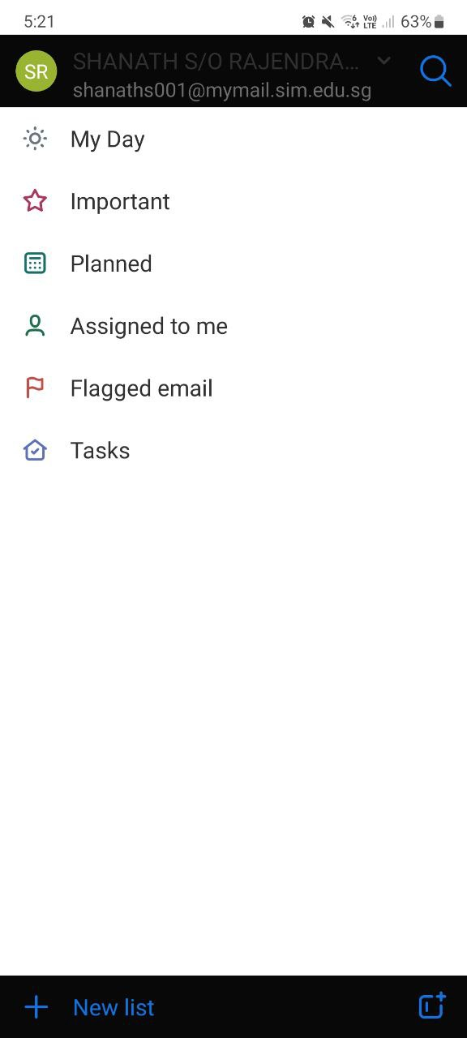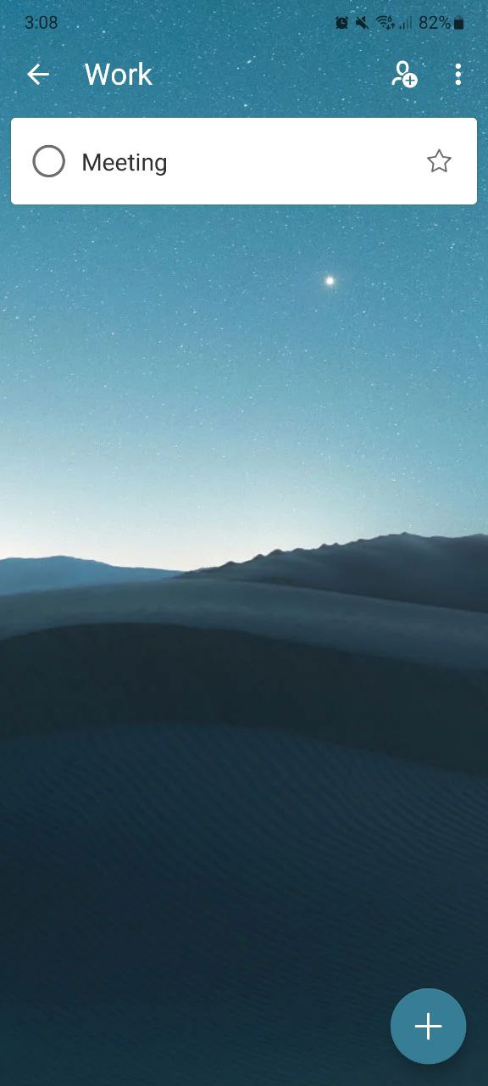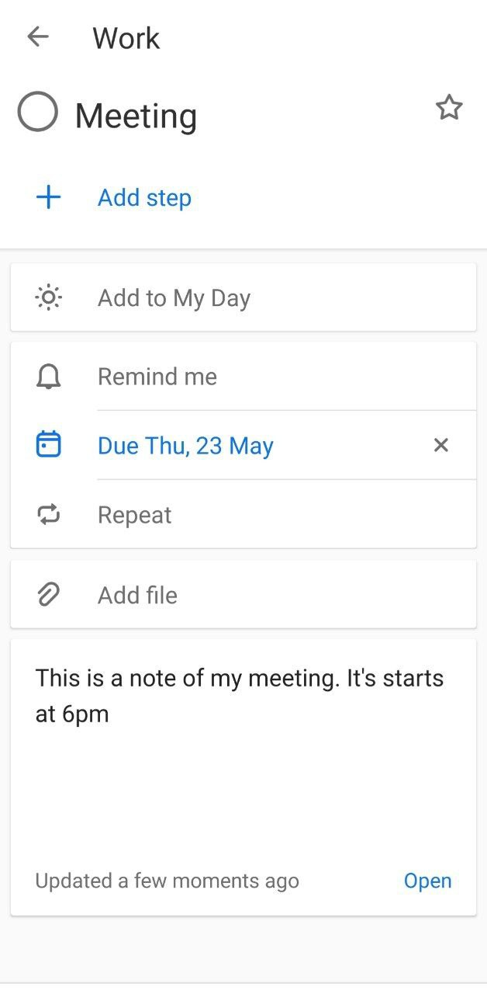

*Fig 1.1 Microsoft To Do Snapshots*

Referring to Figure 1.1, we can see snapshots of the application taken from an Android device. The analysis of the application are as follows:

1. Signing in to use the app

In order to use the application, Microsoft requires you to either sign in into a Microsoft account, or create one. The reason for this is that Microsoft wishes users to be able to sync their Outlook calendar with this task manager application. Whilst providing a seamless integration with their 3rd party applications, denying users access to the application outright because they do not posses a Microsoft account, or don’t intend to, seems to an ideal way for the individual to turn to other competitor products instead [7].

1. No tutorial upon launch

The application had no tutorial upon launch, making it difficult for users to uncover and use all the available features that are available within the application.

1. GUI and Color Design Choice

The application overall aesthetic could be better. The home page as seen in Figure 1.1, shows the top navigation bar being black, whilst the main container being white. I am unable to properly read the account that is logged in due to the contrast of colors, which is one of the key areas in GUI design[8]. Though the positive aspects of this application is that it gives the user freedom to customize the background image of their checklist.

1. Lack of Focus Tool

Our digital world is distracting. A study done by Wang and colleagues[9] noted that students have a considerable amount of digital distractions that they could turn to at a moment’s notice, such as texting and social media. A tool that could aid students in focusing and managing their time, as discussed in the Time Management section, could prove fruitful.

1. Lack of Project Management

The application presents no tool for users to undertake and manage large scale projects, and houses no way to visualize the progress being made. The need for this feature, is backed up by a study done by the U.S. Department of Labor[10] showed that 78% of the population, spent their days engaged in household activities while 44% of the population were engaged in work/work related activities. This indicates users have many tasks to accomplish on a daily basis. A tool to help visualize their accomplishments would be ideal, as it increases their effort exerted and motivation to complete the objective, as seen in the literature review above.

Google Tasks

Google Tasks[11] is a productivity mobile app designed to help users manage their to-do lists and tasks efficiently. It integrates seamlessly with other Google services like Gmail and Google Calendar, allowing users to create, view, and manage tasks across multiple platforms.

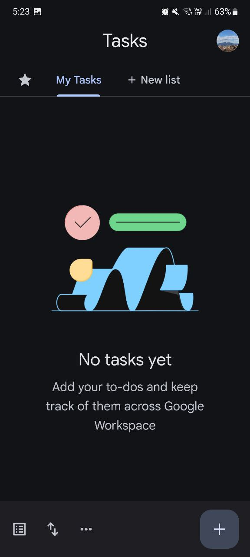 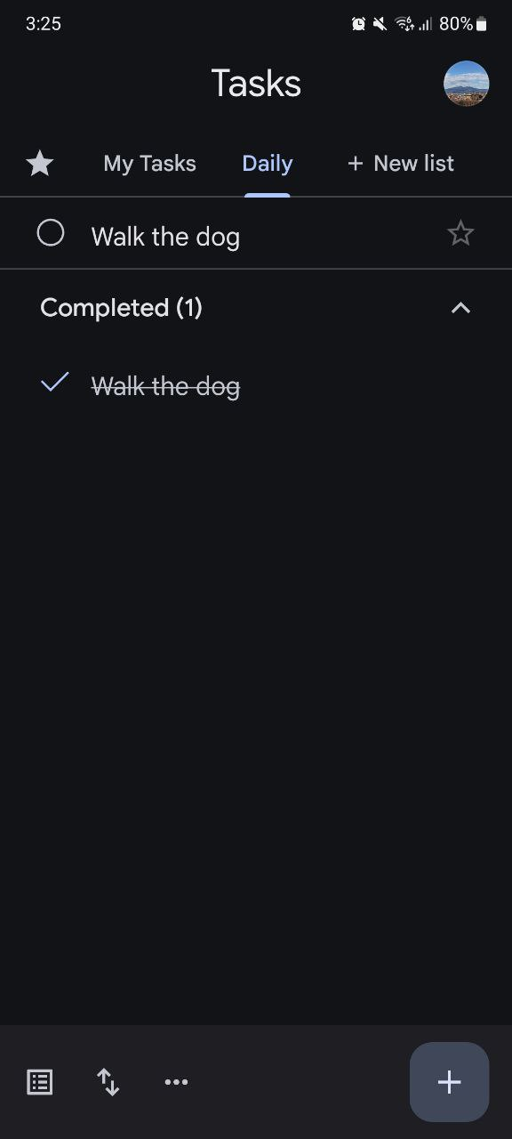

*Fig 1.2 Google Tasks Snapshots*

Referring to Figure 1.2, we can see snapshots of the application taken from an Android device. The analysis of the application are as follows:

1. Good integration of APIs

Unlike Microsoft, Google does not force users to sign into a Google account in order to use their application. Instead, the basic functionality of to-do lists, sub-tasks and notes are available to user, and those that wish to sync their tasks created on Gmail and Google Calendar, can log in to do so.

1. No tutorial upon launch

The application had no tutorial upon launch, making it difficult for users to uncover and use all the available features that are available within the application.

1. GUI and Color Design Choice

The application overall aesthetic is good. Referring to Figure 1.2, we can see the design choice Google has adopted is the flat UI approach[12]. This provides a clean and easy interface to navigate.

1. Lack of Focus Tool

Like Microsoft, a tool that could aid students in focusing and managing their time, as discussed in the Time Management section, could prove fruitful.

1. Lack of Project Management

Like Microsoft, this application presents no tool for users to undertake and manage large scale projects, and houses no way to visualize the progress being made, as seen in the literature review above.

1. Lack of image attachments

The application does not allow users to upload and attach images as part of their notes.

Tasks by Pocket Brilliance

Tasks by Pocket Brilliance[13] Limited is another task manager application available from the Google Play Store. A review of this application reduces the bias of only analyzing task manager applications from already established technology giants.

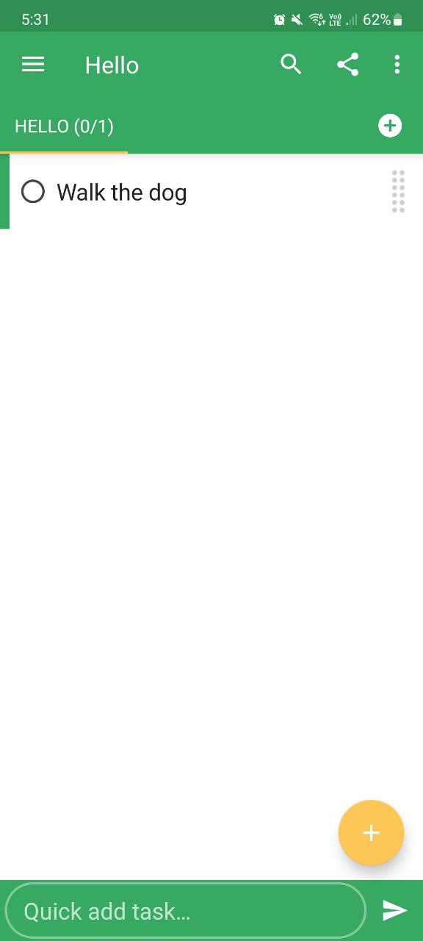 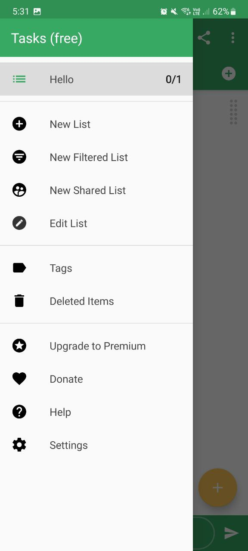

*Fig 1.3 Tasks by Pocket Brilliance Snapshots*

Referring to Figure 1.3, we can see snapshots of the application taken from an Android device. The analysis of the application are as follows:

1. Minimal API and Sync

This application uses minimal API such as calendar and syncing the application and its data across multiple devices. It does not require users to log in or create account. However, it does require users to purchase the premium version of the application, in order to synchronize across devices.

1. Privacy

This application prides itself in no collecting and sharing user’s data to third party services, which is a good practice to entice users to use their application instead, as data collection from corporations is rampant in today’s world[14]. There is no ethical breach.

1. Poor tutorial and settings page

The application has a poor tutorial then only activates once users start to interact with the application. It does not give the option to replay the tutorial in the settings page, which is extremely cluttered with many nuanced setting parameters.

1. GUI and Color Design Choice

The application overall aesthetic is good. Referring to Figure 1.3, we can see the design choice it has adopted, is the flat UI approach.

1. Lack of Focus Tool

Once again, a tool that could aid students in focusing and managing their time, as discussed in the Time Management section, could prove fruitful.

1. Lack of Project Management

Once again, this application presents no tool for users to undertake and manage large scale projects, and houses no way to visualize the progress being made, as seen in the literature review above.

Key Takeaways

The table below highlights the positives and negatives aspects of the formerly reviewed existing applications on the market. The findings uncovered from the analysis, that will be carried over to my application, are highlighted under the “Carry Over” column. These features were selected to provide the best experience and features available to users, whilst eliminating potential inconveniences.

|  |  |  |  |
| --- | --- | --- | --- |
| Name of Application | Good Practices | Bad Practices | Carry Over |
| Microsoft To Do | * Allows customization via images | * Forcing users to sign in * Bad design principle * No tutorial * No focus tool * No project tool | * Allow image customization * Include focus & project tool * Include a tutorial * Do not force users to sign in * Select proper design principles |
| Google Tasks | * Great UI design choice, flat principle | * No tutorial * No focus tool * No project tool * Can’t attach images | * Carry over flat principle and minimalism design * Include focus & project tool * Include a tutorial |
| Tasks by Pocket Brilliance | * Minimalize use of 3rd party API * No ads or data collection * Minimalist and flat UI approach | * No focus tool * No project tool * Overwhelming settings page | * Use 3rd party services only when necessary * Do not collect data or house advertisements * Adopt a minimalist approach |

Conclusion

In summary, the literature review comprised of three key components. We discussed why the need for having a time management tool is important for students to maintain productivity and focus through a review of a study conducted by experts in the field, regarding the use of micro breaks when accomplishing a task. The need for goal visualization for adults in a work environment was also reviewed, and we saw the positive impact it made on individuals when a visualization tool was present. Finally, we compared previous work done by competitors, and analyzed their strength and weaknesses, and what I will be carrying and not carrying over into my application, based off a thorough analysis and review.

## SWOT

The following is a SWOT analysis of the proposed application. SWOT is an acronym for Strengths, Weaknesses, Opportunity and Threats. It is a strategic planning and strategic management technique used to help a person or organization identify the aforementioned qualities of a project. This analysis is performed to provide insights as to how the application might evolve in the later stages of the project, especially in the development phase, should it be necessary.

|  |  |
| --- | --- |
| Strengths | Weaknesses |
| Has a tutorial guiding users on how to use the application.  Has a focus tool to help students and adults management their time in work or academic environment.  Has a project management tool to aid in the undertaking of large scale projects, that require numerous sub-tasks.  Contains a visualization tool under project management, to provide motivation to users.  Incorporates neomorphism design, to combine the simplicity of minimalism, whilst retaining colors and shadows. | Only being tested and deployed for Android devices.  Because is it not using the OS’s native language, performance might be an issue, though high unlikely. |
| Opportunity | Threats |
| Can be tested and deployed for Apple devices in the future, should the hardware become available. | Can be outcompeted by large corporations that have already established their own task manager applications, such as Google and Microsoft.  Difficult to market and advertise the mobile application. |

# Project Design

## Domain & Users

The domain of the project falls under productivity, and the mobile application being built in this project is intended for students and young adults who possess an Android mobile device. To be able to deliver the mobile application to the intended audience, I will attempt to upload and publish the application to the Google Play Store.

## Justification of Selected Features

The reason the application is being targeted towards students and young adults, has been highlighted in the literature review and introduction of this project. The modern world is increasing in terms of responsibilities, and digital distractions. A task manager application that employs time management techniques, has shown to improve student’s academic performance, whilst goal visualization, has shown to help adults such as athletes and managers, to exert more effort to reach their end goal.

Therefore, to address time management, the task manager application will house a timer, employing the 52/17 technique[15]. An individual will time themselves to work for 52 minutes and rest for 17 minutes. And in regards to goal setting and visualization, the mobile application will house a project management tool that will allow users to undertake large sets of tasks, whilst being able to visualize their progress, via a horizontal progress bar, providing motivation to see the project through to end, as discussed in the literature review. There will also be a statistics page, where users can see over a period of time, how many tasks they have completed. This will provide statistical data, that users can infer about themselves. The application must also house the ability to use images as notes.

Analysis of existing application has also shown proper tutorials, or the lack thereof, emphasizing the need for a proper tutorial, guiding users to all the features available to them. Thus, its one of the features I have selected for my application.

|  |
| --- |
| Selected Features |
| Project Management Tool |
| Focus Tool |
| Checklist |
| Notes |
| Tutorial |

## Technology & Methodology

The chosen technology to build this mobile application is React Native[16] and Expo[17]. React Native is a JavaScript framework developed by Meta[18], with the aim of allowing developers to use a single language, in this case JavaScript, to develop applications for a particular platform or operating system using the platform's own tools and languages.

Expo is a framework and platform built around React Native that simplifies mobile app development, building, and deployment. It provides a managed workflow with a suite of pre-configured libraries and APIs, enabling me to start building apps quickly without dealing with native code configurations. The Expo CLI and Expo Go app streamline development, allowing for instant previewing on physical devices.

This mean I am able to develop the task manager mobile application for Android devices without the need to learn Android’s native language of Java and Kotlin. On top of that, the React Native based mobile application built in this project, can also run on IOS devices, such as iPhones, giving this project the room for upgradability and deployment to Apple devices, should one come into my possession for testing, in the future.

The main APIs that will be used to build this application are as follows:

* Expo Calendar
* Expo Camera and ImagePicker
* Expo Notifications and Permissions
* Expo AsyncStorage

The software development for this project will utilize Sprints[19] and User-Centered Design (UCD)[20], methodologies that originate from Agile software development. I have selected these approaches because I believe they are the most effective for addressing the project's requirements and the characteristics of the final product. Sprints are bursts of effort that serve as repeatable stages within a software development cycle. User-Centered Design (UCD) is a design approach that focuses on the needs, preferences, and limitations of end-users at every stage of the design process and involves actively engaging users through feedback, and iterative testing.

The task manager mobile application is heavily focused on user experience rather than complex technical features. Therefore, a UCD approach allows me to better understand my users, and perform iterative increments and improvement based on their feedback. This ensures that I consistently consider my users' needs and stops me from being influenced by my own assumptions about how the application should be delivered.

## Low Fidelity Wireframe

The figures below showcase the low fidelity wireframes that will be used in the first round of user-based testing.

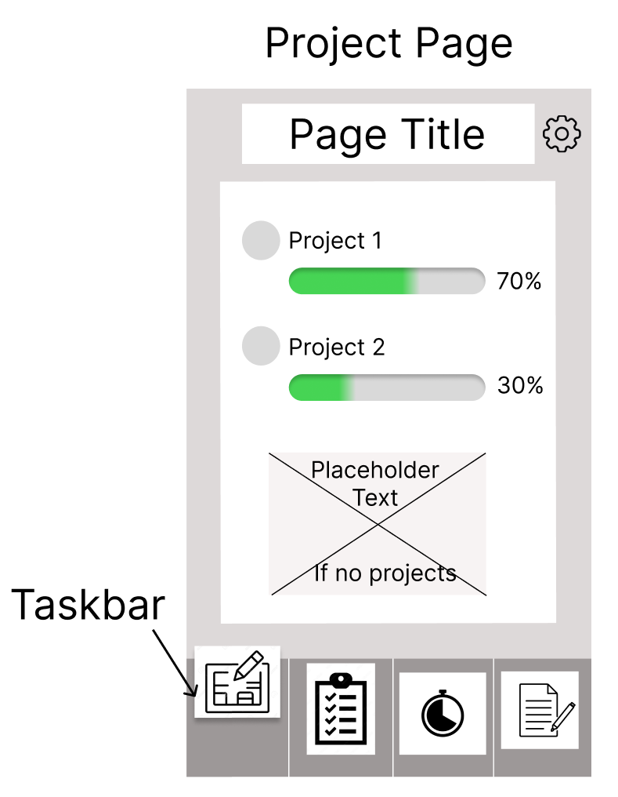

*Fig 1.4 Project Page Wireframe*

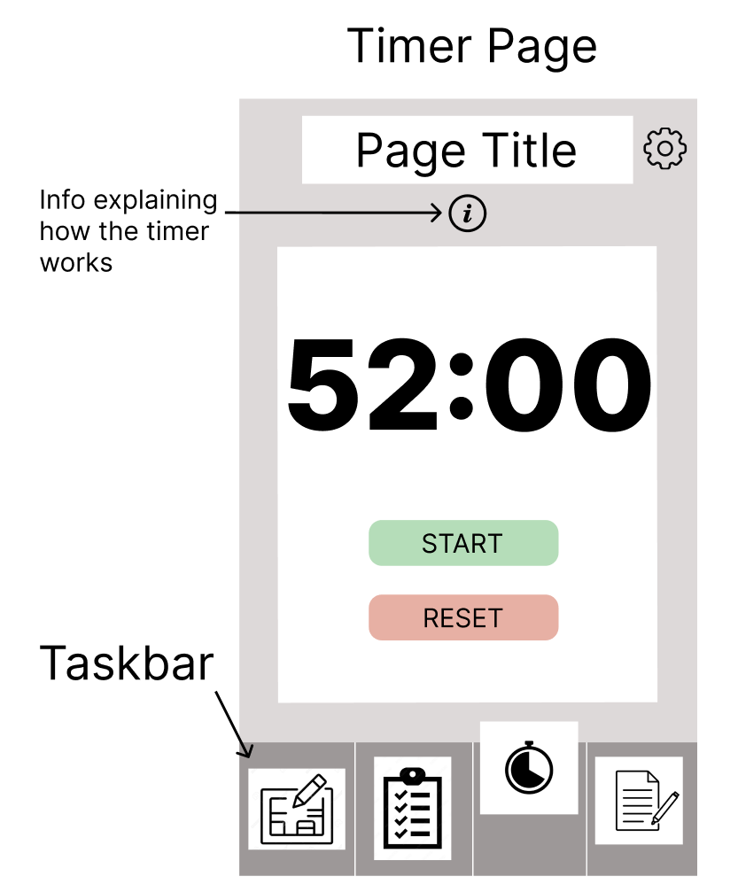

*Fig 1.5 52/17 Timer Page Wireframe*

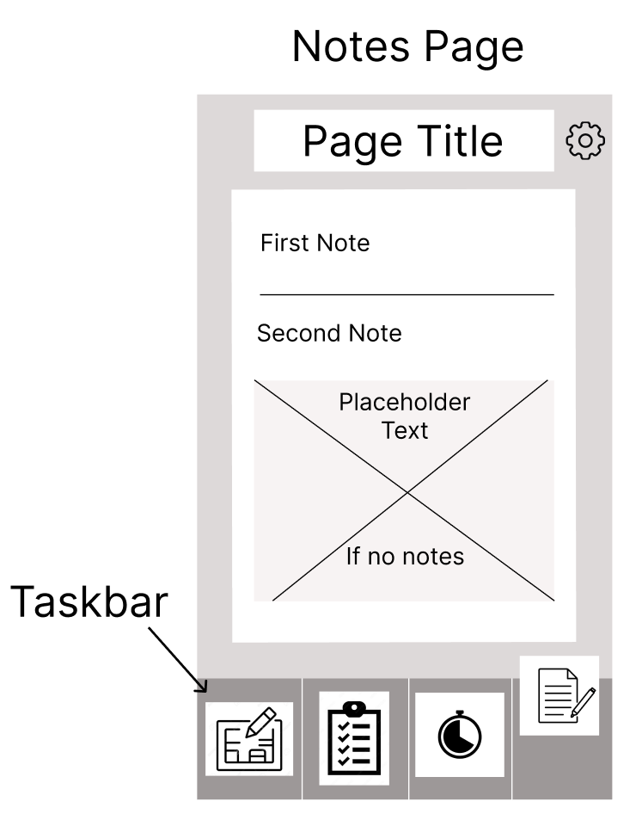

*Fig 1.4 Notes Page Wireframe*

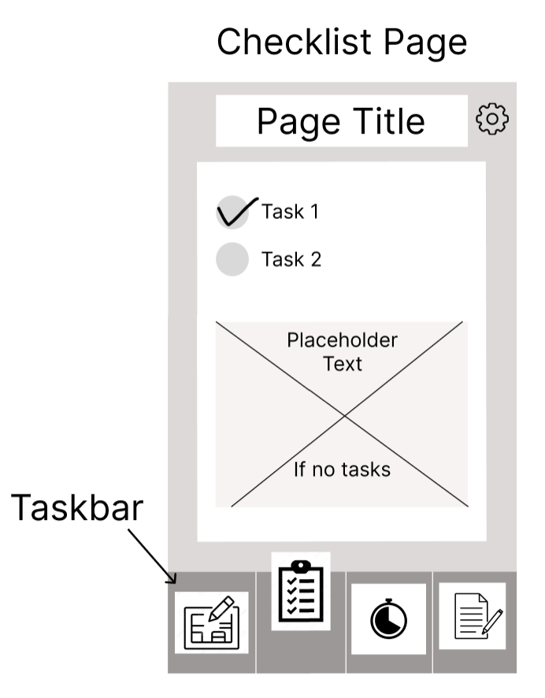

*Fig 1.4 Checklist Page Wireframe*

## User Testing of Wireframe

The wireframe proposed above underwent a user testing via the use of Google Surveys.

## Gantt Chart

The figures below show the Gantt Chart developed to help guide me through the entirety of the final project.

The key milestones are as follows:

* Completion of Design Phase – June 7th
* Submission of Preliminary Report – June 11th
* Completion of Development Phase – August 15th
* Completion of Testing Phase – August 24th
* Submission of Final Project, in its entirety – September 9th

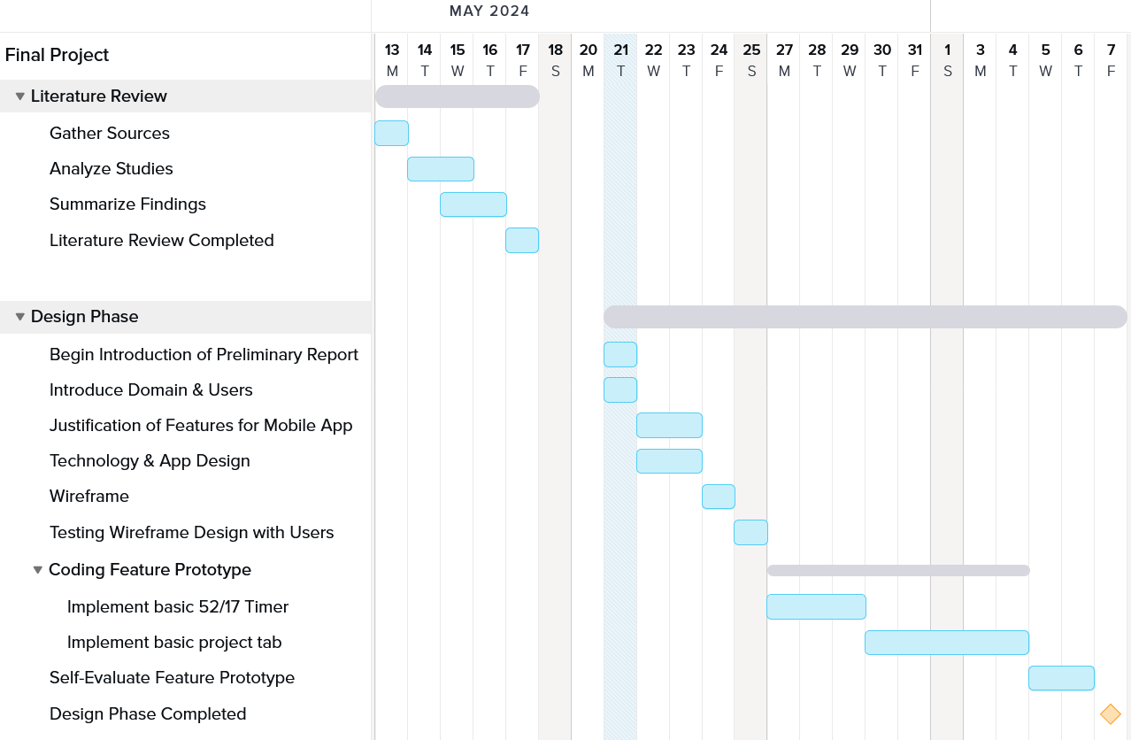

*Figure 2.1 Gantt Chart*

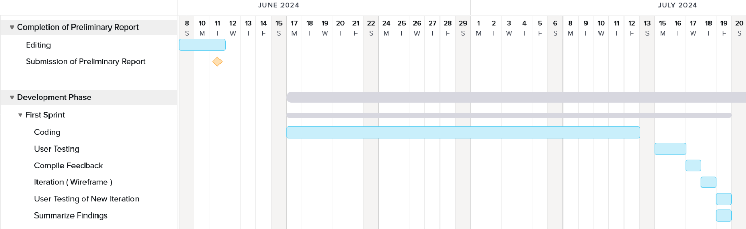

*Figure 2.2 Gantt Chart*

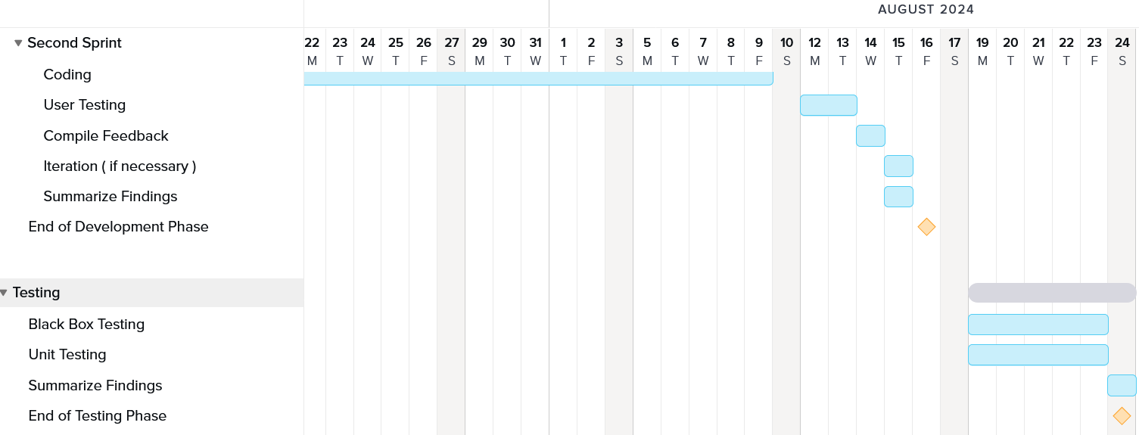

*Figure 2.3 Gantt Chart*

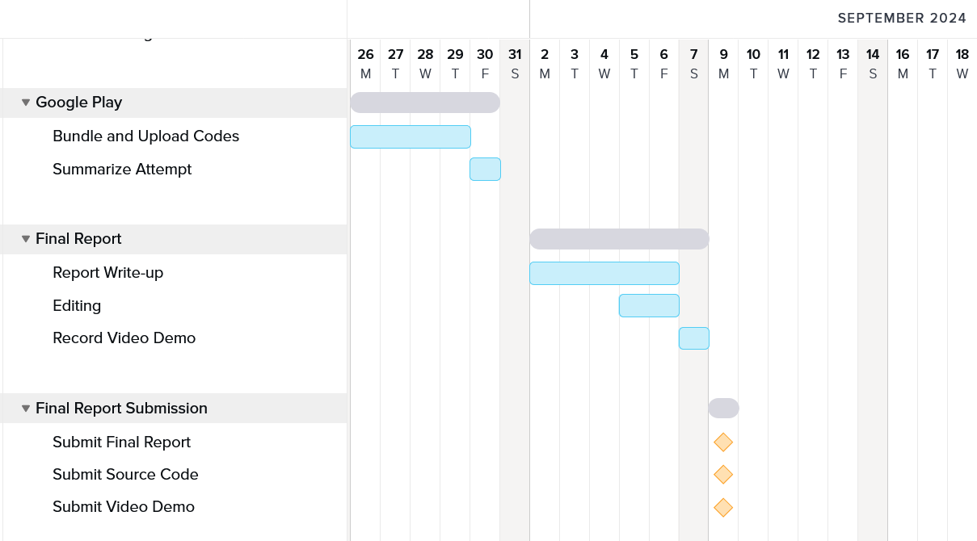

*Figure 2.4 Gantt Chart*

# Feature Prototype

The features that were chosen for an initial prototype for self-evaluation were…

# References

[1] Nasrullah_PhD, S. and Khan_PhD, M.S. (2015). The impact of time management on the students’ academic achievements. Journal of Literature, Languages and Linguistics, 11, pp.66-71.

[2] Razali, S.N.A.M., Rusiman, M.S., Gan, W.S. and Arbin, N. (2018). The Impact of Time Management on Students’ Academic Achievement. Journal of Physics: Conference Series, [online] 995(1), p.012042. doi:https://doi.org/10.1088/1742-6596/995/1/012042.

[3] Albulescu, P., Macsinga, I., Rusu, A., Sulea, C., Bodnaru, A. and Tulbure, B.T. (2022). ‘Give me a break!’ A systematic review and meta-analysis on the efficacy of micro-breaks for increasing well-being and performance. *PLOS ONE*, [online] 17(8), p.e0272460. doi:https://doi.org/10.1371/journal.pone.0272460.

[4] Cheema, A. and Bagchi, R. (2011). The Effect of Goal Visualization on Goal Pursuit: Implications for Consumers and Managers. Journal of Marketing, 75(2), pp.109–123. doi:https://doi.org/10.1509/jm.75.2.109.

[5] Wright, P. and Kacmar, M. (1994). Goal Specificity as a Determinant of Goal Commitment and Goal Change . [online] www.sciencedirect.com. Available at: <https://www.sciencedirect.com/science/article/abs/pii/S0749597884710594#preview-section-cited-by>.

[6] Microsoft.com. (2024). To Do List and Task Management App | Microsoft To Do. [online] Available at: <https://www.microsoft.com/en-sg/microsoft-365/microsoft-to-do-list-app>

[7] Underwood, J. (2017). Learning 001: Sometimes you shouldn’t force user login, even if everyone says you should. [online] Medium. Available at: <https://medium.com/@JUnderwood/learning-001-sometimes-you-shouldnt-force-user-login-even-if-everyone-says-you-should-96dd4c416487>

[8] Figma (2023). 5 key UI design principles— and how to use them | figma. [online] Figma. Available at: <https://www.figma.com/resource-library/ui-design-principles/>.

[9] Wang, C.-H., Salisbury-Glennon, J.D., Dai, Y., Lee, S. and Dong, J. (2022). Empowering College Students to Decrease Digital Distraction through the Use of Self-Regulated Learning Strategies. Contemporary Educational Technology, [online] 14(4). Available at: <https://eric.ed.gov/?id=EJ1364826>.

[10] Bureau Of Labor Statistics (2023). AMERICAN TIME USE SURVEY — 2022 RESULTS. [online] Available at: <https://www.bls.gov/news.release/pdf/atus.pdf>.

[11] play.google.com. (n.d.). Google Tasks – Apps on Google Play. [online] Available at: <https://play.google.com/store/apps/details?id=com.google.android.apps.tasks&hl=en_SG&gl=US&pli=1>

[12] DesignerUp. (2023). 6.5 of The Most Popular UI Design Trends and Styles Explained. [online] Available at: <https://designerup.co/blog/here-are-6-5-of-the-most-popular-ui-design-trends-and-how-to-design-them/>.

[13] play.google.com. (n.d.). Tasks: to do list & tasks – Apps on Google Play. [online] Available at: <https://play.google.com/store/apps/details?id=com.tasks.android&hl=en_SG&gl=US>

[14] www.privacyjournal.net. (2022). Big-Tech Data Collection: Protect Your Info 2024. [online] Available at: <https://www.privacyjournal.net/big-tech-data-collection/>.

[15] www.larksuite.com. (n.d.). Unveiling the 52-17 Rule: A Guide to Boosting Productivity. [online] Available at: <https://www.larksuite.com/en_us/topics/productivity-glossary/52-17-rule>

[16] React Native (2022). React Native · A framework for building native apps using React. [online] reactnative.dev. Available at: <https://reactnative.dev/>.

[17] Expo. (n.d.). Expo. [online] Available at: https://expo.dev/.

‌[18] Meta (2024). Meta | Social Metaverse Company. [online] Meta | Social Metaverse Company. Available at: https://about.meta.com/.

[19] Simplilearn.com. (2020). *Agile Sprint in Software Development: Definition, Process, & Roles*. [online] Available at: <https://www.simplilearn.com/agile-sprint-article>

[20] Novoseltseva, E. (2019). *User-Centered Design: An Introduction - Usability Geek*. [online] Usability Geek. Available at: <https://usabilitygeek.com/user-centered-design-introduction/>

‌

‌